Mojmir Mrak
PhD, Jean Monnet Chair
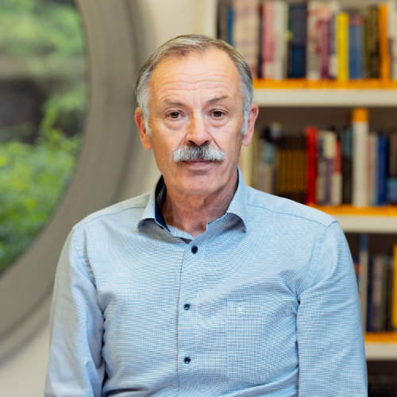

Mojmir Mrak is a Full Time Professor and a Jean Monnet Chair holder at the Academic Unit for Money and Finance at the Faculty of Economics, University of Ljubljana. He has also been a regular visiting professor at the Wirtschaftsuniversitaet in Vienna (Austria) and at Burgundy School od Business in Dijon (France). His main research fields include international capital flows, national and EU public finances, and EU accession. Mojmir Mrak is author, coauthor and editor of numerous books published by international publishers and respective international journals. He serves also as a member of editorial boards and / or reviewer for several international journals. Mojmir Mrak has more than 25 years of experience in designing and implementing the Slovenian Government’s policy in areas of international finance and EU accession / financial issues. Between 1992 and 1996, he was the Chief External Debt Negotiator of the Republic of Slovenia and was responsible for Slovenia’s early credit arrangements with the EBRD and with the IBRD. Later on, between 1997-2004, he acted as the Chief Advisor of the Slovenian Government on financial aspects of the country’s EU accession process. Over the recent years, he has been providing analytical support for Slovenia’s negotiations with respect to the medium-term financial perspectives of the EU for the 2007-2013, 2014-2020 and 2012-2027 periods. Mojmir Mrak also had numerous consultancy assignments on macro-fiscal and EU accession issues for international organizations as well as for governments of several countries in the region of South Eastern Europe. Over the recent years, Mojmir Mrak cooperates as senior program advisor with Centre of Excellence in Finance, a leading international institution providing assistance on public finance issues to the countries of the region.

